PRACTICAL 10
Aim: Create DTD file for student information and create a valid well-formed XML document to store student information against this DTD file.

Stud.dtd
<!ELEMENT students (student)*>
<!ATTLIST student sem CDATA "III">
<!ELEMENT student (rollno,name,marks)>
<!ELEMENT rollno (#PCDATA)>
<!ELEMENT name (#PCDATA)>
<!ELEMENT marks (#PCDATA)>

Student.xml
<?xml version="1.0" encoding="UTF-8"?>
<!DOCTYPE students SYSTEM "Stud.dtd">
<students>
<student sem="VI">
<rollno>37</rollno>
<name>Abc</name>
<marks>78</marks>
</student>
<student>
<rollno>36</rollno>
<name>Xyz</name>
<marks>78</marks>
</student>
</students>

- OUTPUT:
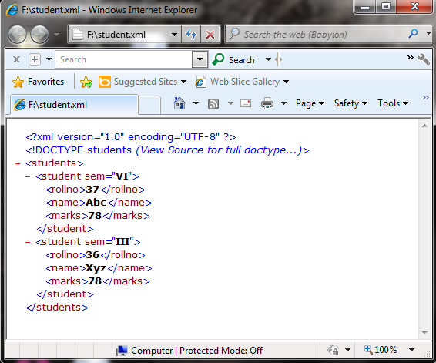

OUTPUT:
